Jenkins Setup:

1. Download Jenkins.war file from <http://updates.jenkins-ci.org/download/war/>

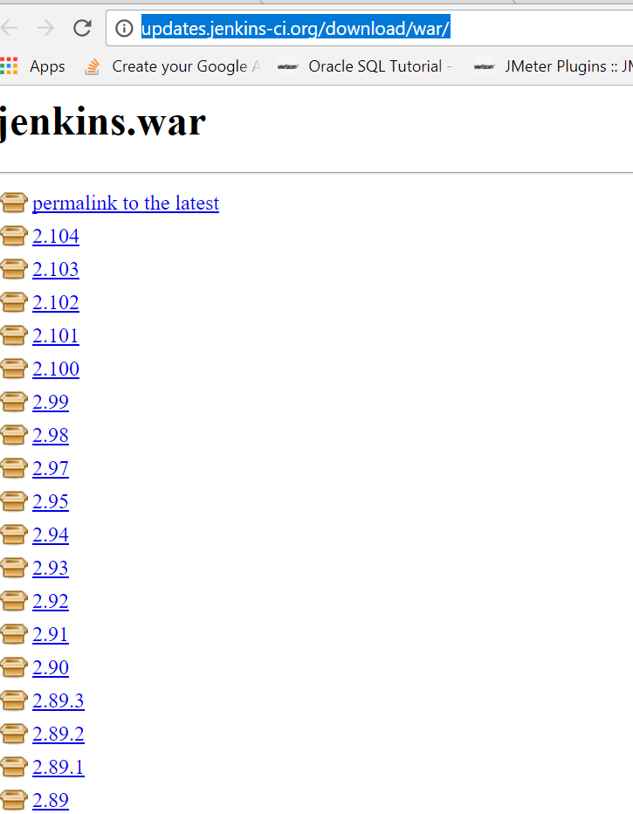

1. Create a folder Name : Jenkins and put your .war file
2. Open CMD and copy jenkins folder path and write cd + folder path :

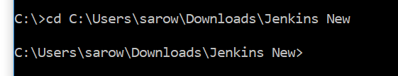

1. Check java : java –version
2. If java installed in your machine than go next or install java
3. Write below code to install Jenkins: if your default port 8080 not used than –httPort= 8080 or 9090
4. 
5. If you don’t write port than it will install default port 8080
6. Press Enter and Jenkins will start
7. Open any browser and write and use your port number default 8080 or any port like 9090

localhot/9090/manage or <http://localhost:8080/login?from=%2Fmanage>

1. Ist time will see below window
2. 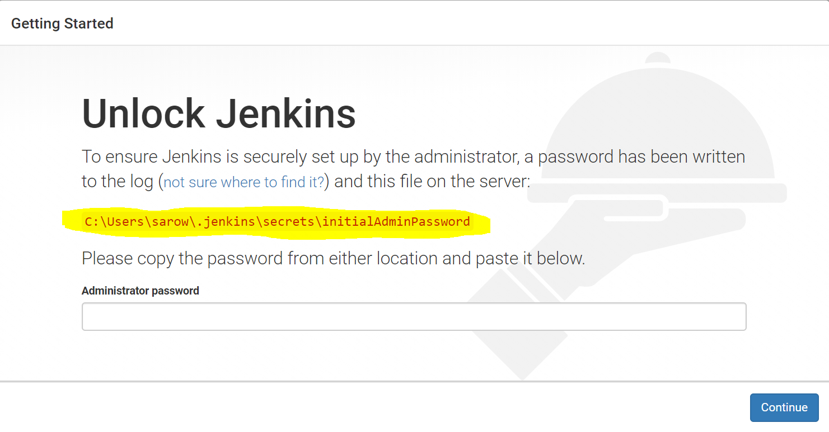
3. Open any folder and copy & paste yellow path
4. 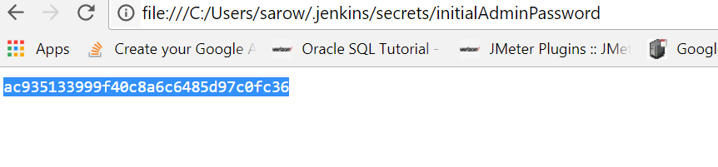
5. You will get admin password of your machine and copy it than paste it in Jenkins
6. 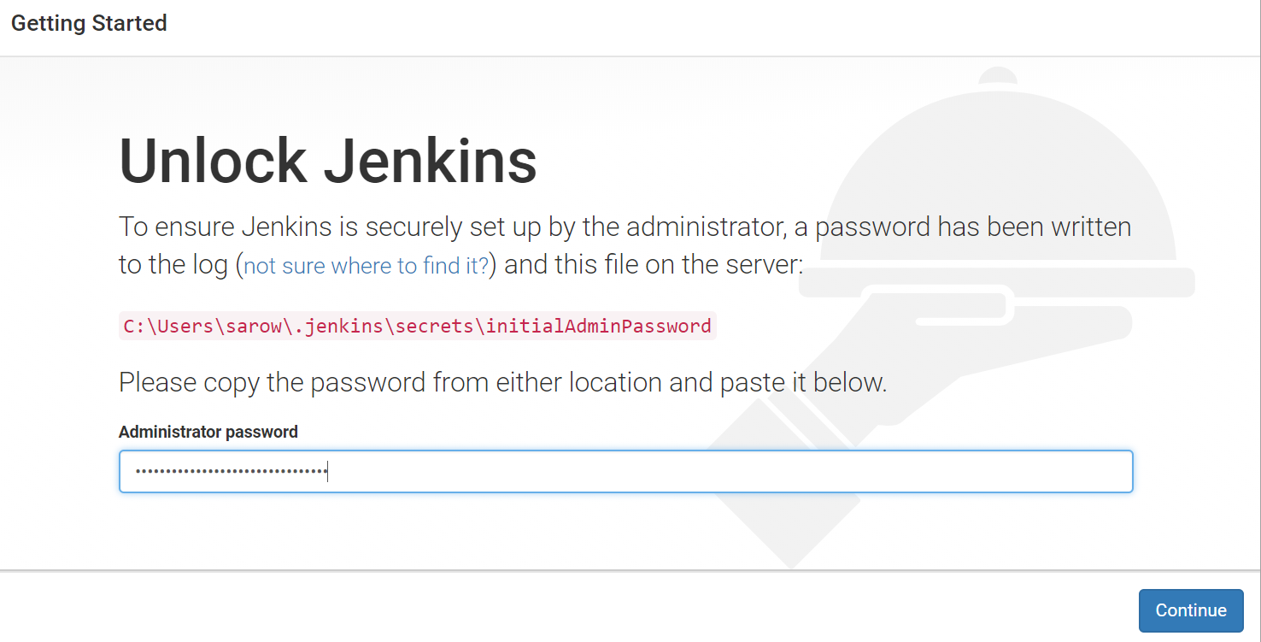
7. Click continue
8. Write <http://localhost:8080> or 9090(which port you mention in CMD)
9. 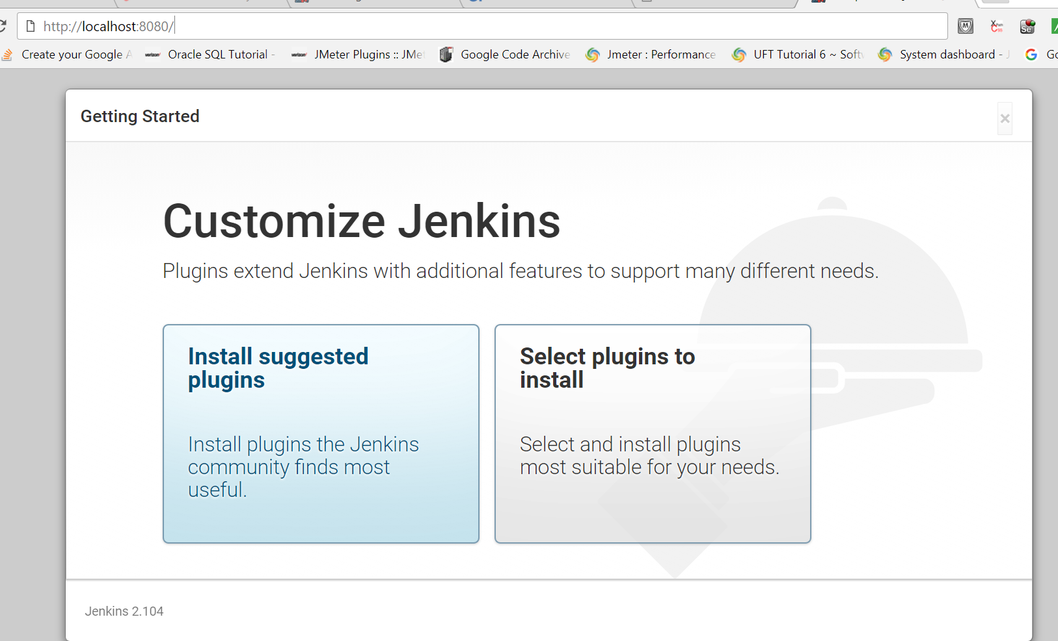
10. Click install suggested plugins
11. All necessary plugin will install
12. It will tell you to create account 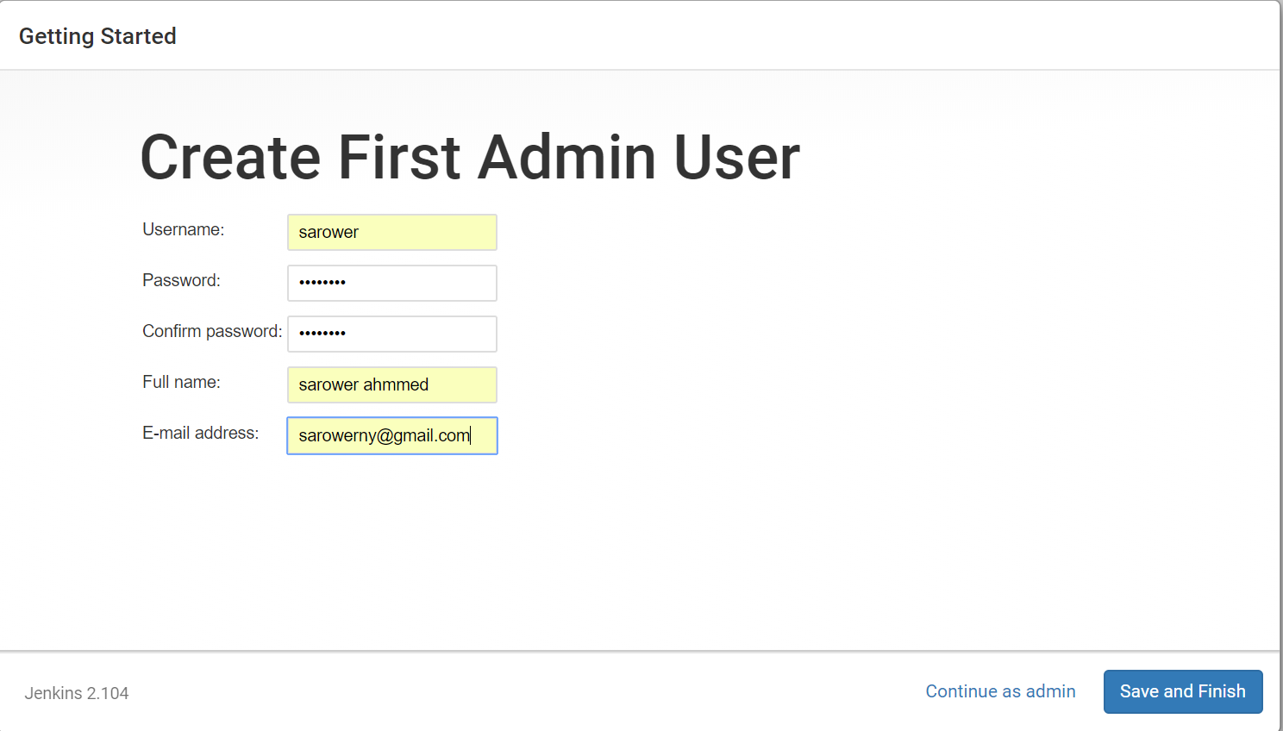
13. Click Save and Finish
14. 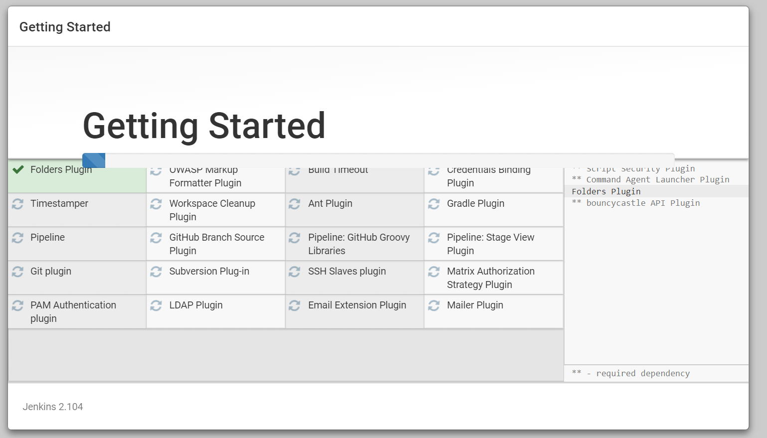
15. You can see Jenkins UI
16. 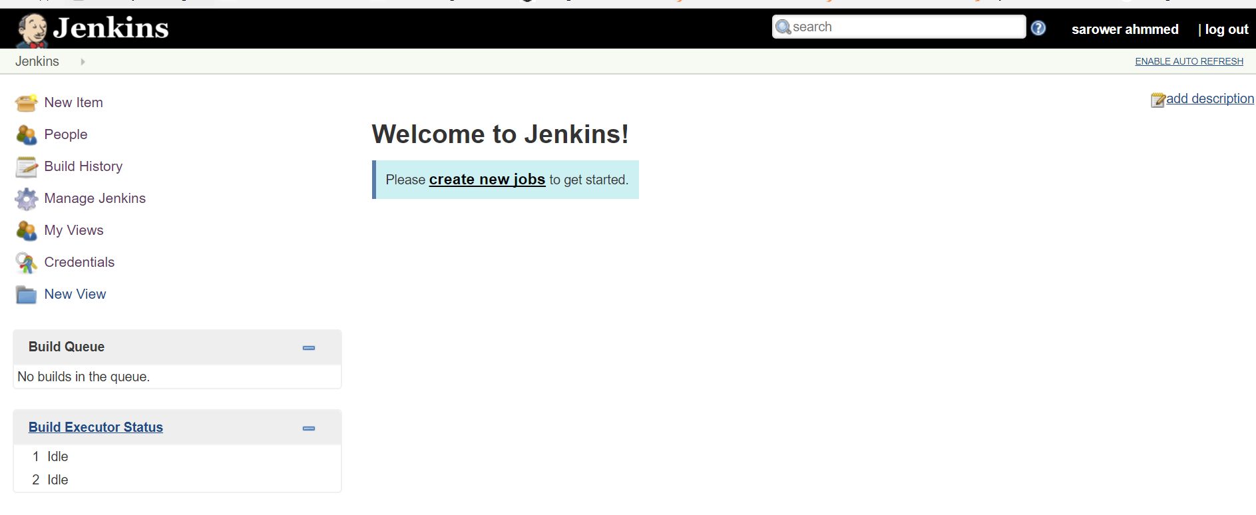

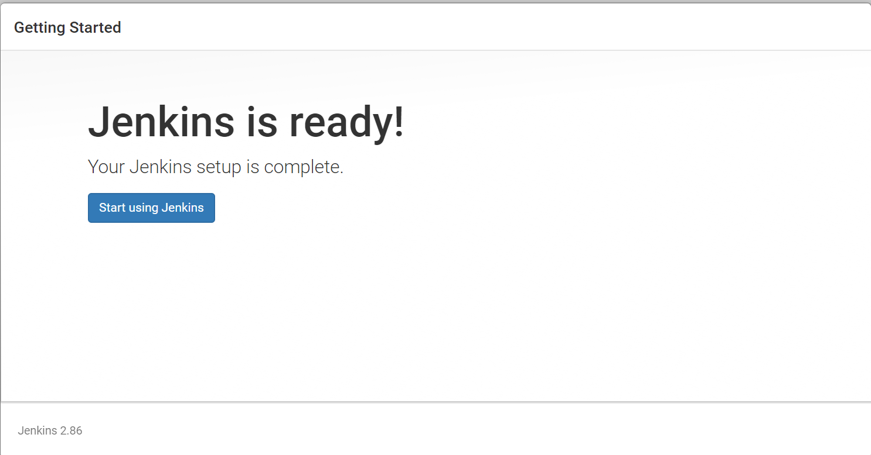

1. Now Jenkins UI ready to use
2. Click Manage Jenkins 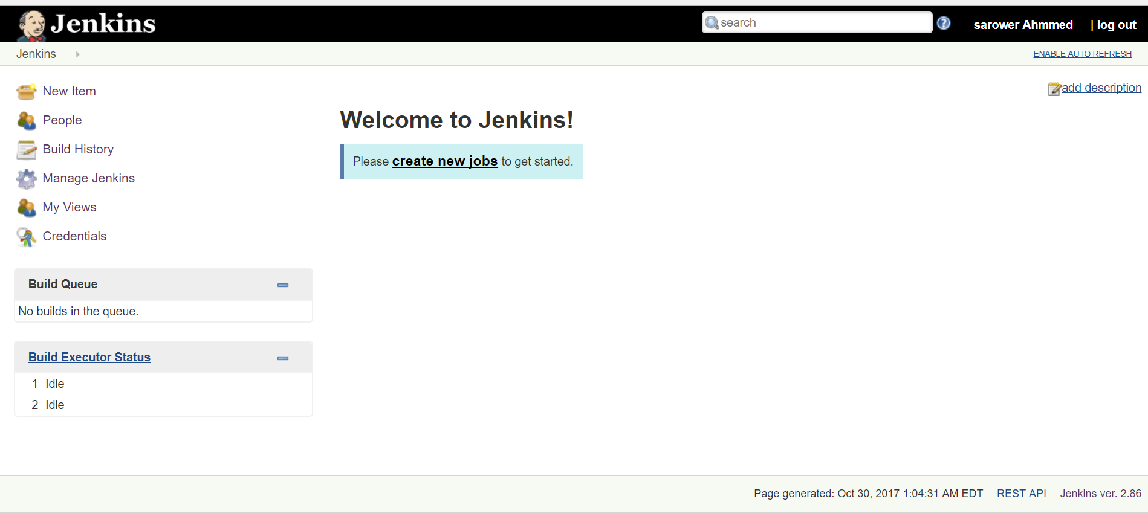
3. Click Global Tool Configuration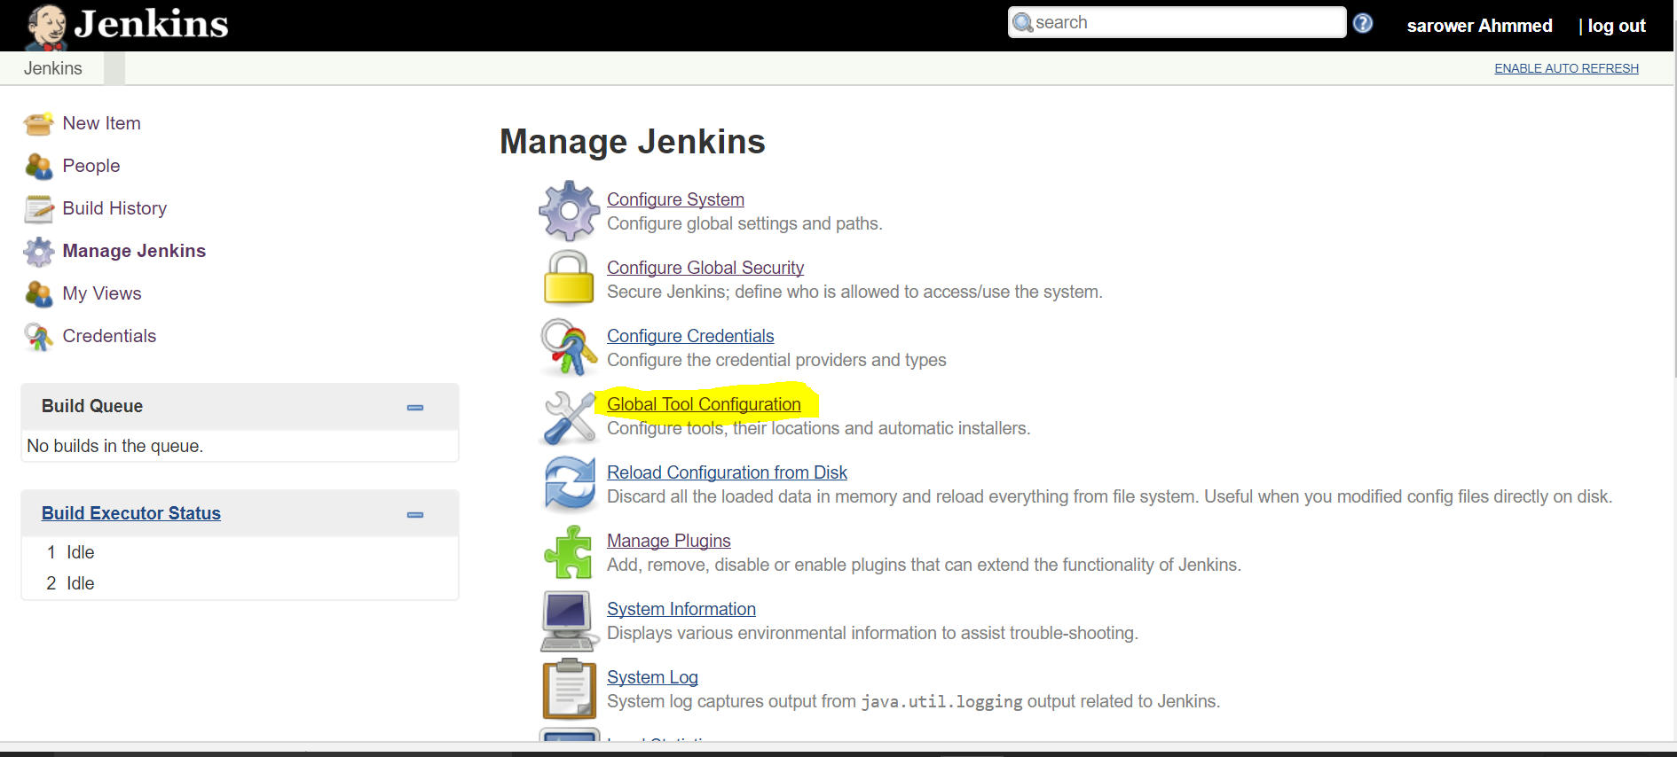
4. Click Add JDK 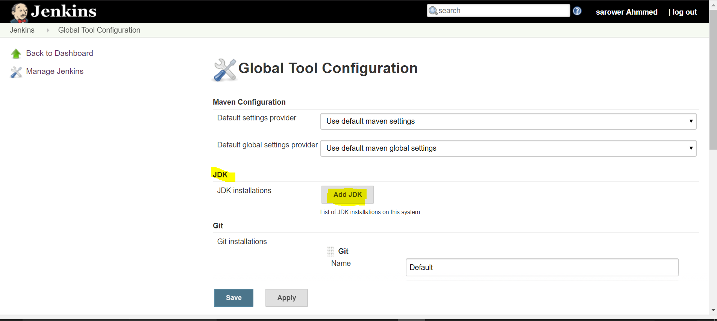
5. Name: JAVA_HOME and select JDK version. Check your JDK version and select your machine JDK version 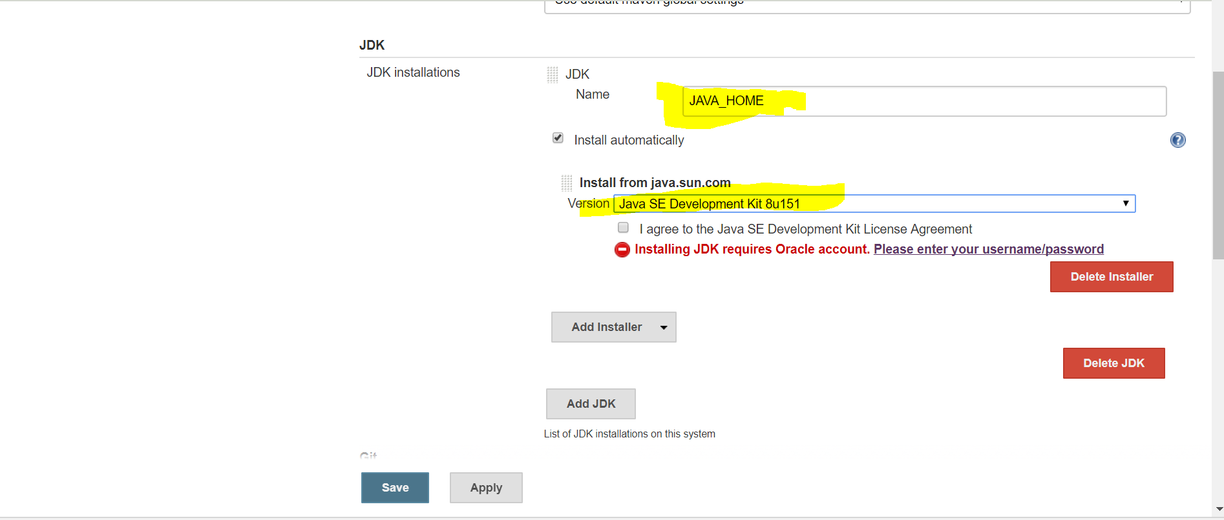
6. Click agree and save 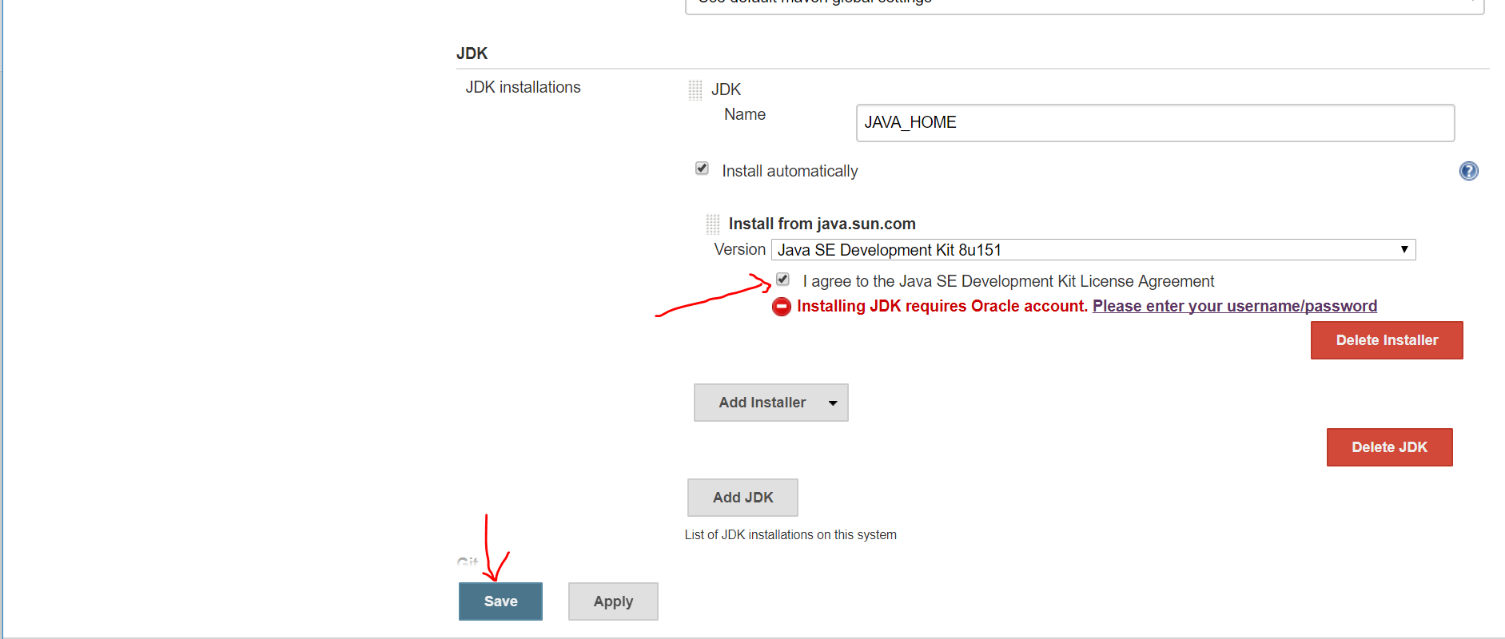
7. Click manage plugin again 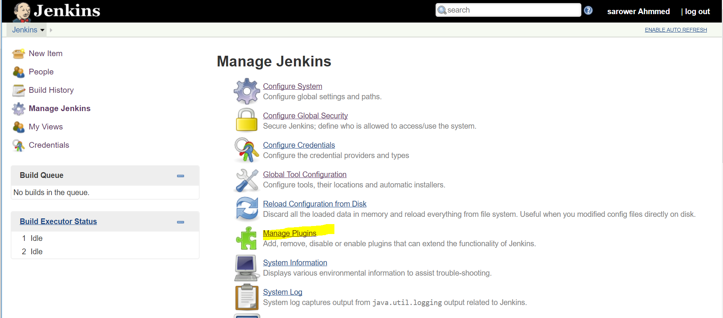
8. Click Available plugin> write GitHub in search box> check click GitHub Authentication plugins >install without restart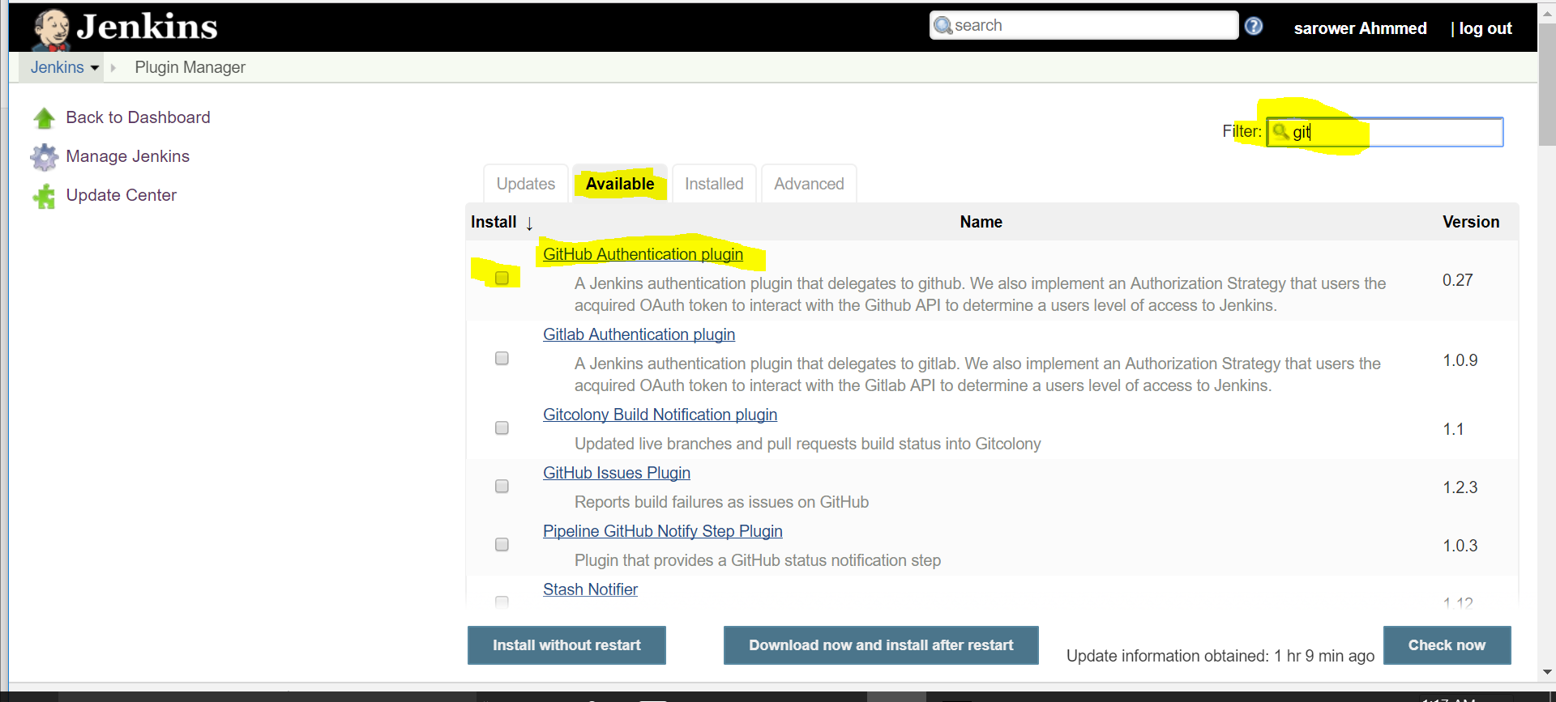
9. Go manage plugin> Available plugins> write Maven in search box> check click Maven Integration plugins> click check box > install without restart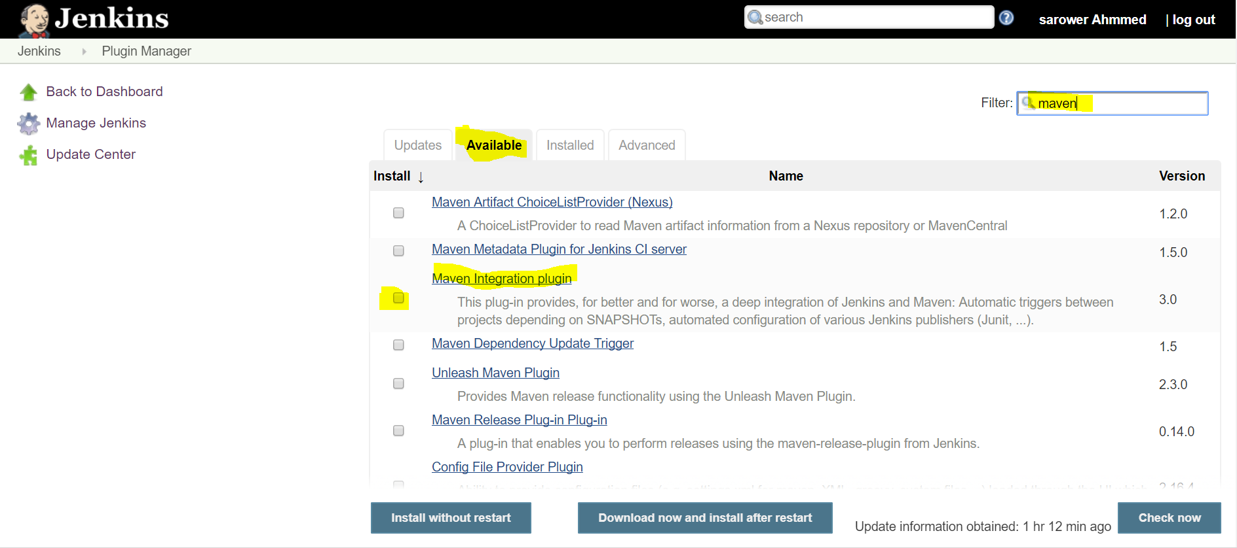
10. Go manage plugin> Available plugins> write Cucumber in search box> check click Cucumber reports , cucumber json test reporting ,cucumber trend reportsand cucumber plugins> click check box > install without restart (U can select all cucmber if u need slck or perf)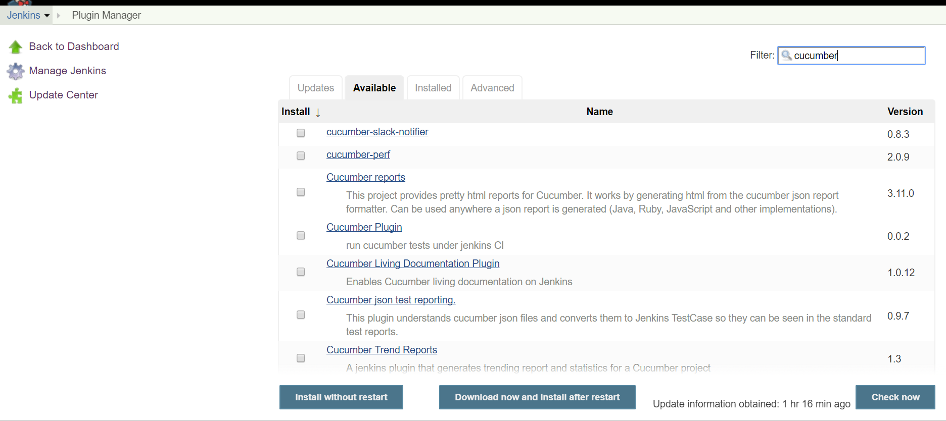
11. Click new Item 
12. Write project any name and select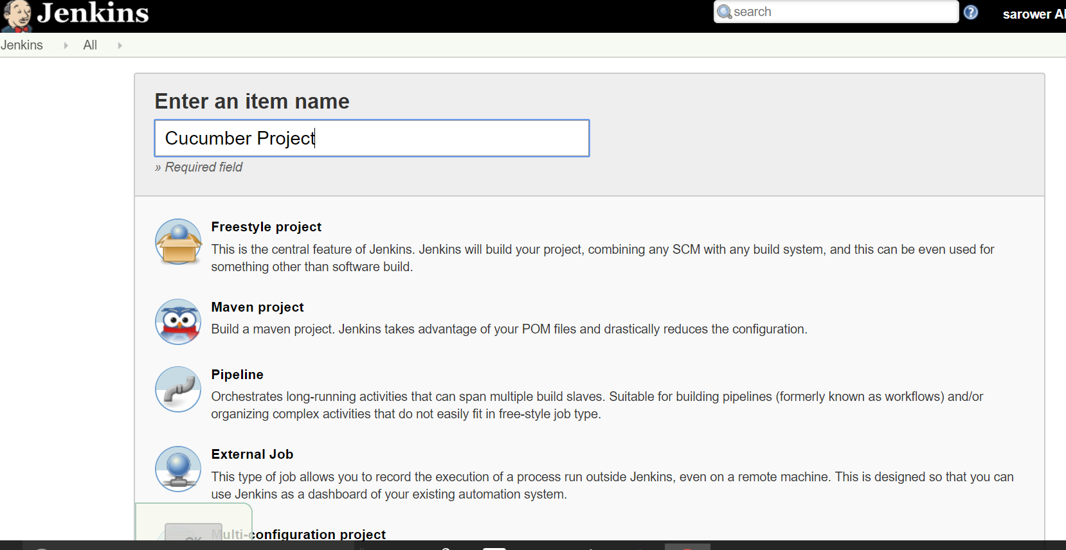
13. I will show you next part in class